**MS, ADBMS**

**Given Database**

Product (pid, name, price)

Purchase (pid, cid, store)

Customer (cid, name, city)

1. Draw a logical query plan for the following SQL queries. **5**

SELECT DISTINCT x, store

FROM Purchase x, Customer y

WHERE x.cid = y.cid

and y.city = ’Seattle’

2. Write a SQL query that is equal to the following logical plan. **5**

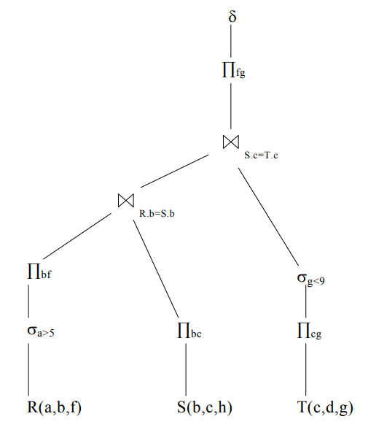

3. Consider the following two physical query plans. Give two reasons why plan **B** may be faster than plan **A**. Explain each reason. **5**

